Name : Moneeb Ahmed Al-ALawneh

1. Draw the ER diagram or Schema diagram for the previous scenario :

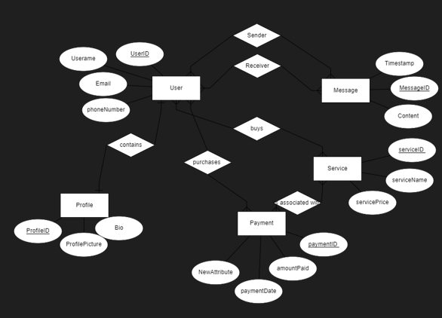

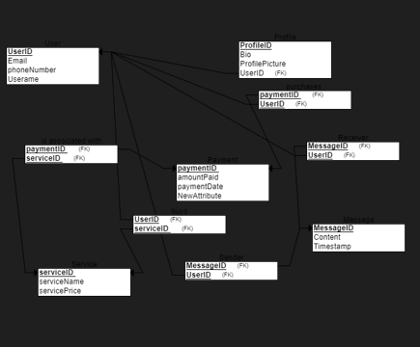

1. Create all the required tables for the system :

CREATE TABLE Users (

userID INT PRIMARY KEY,

userName VARCHAR2(100),

userEmail VARCHAR2(100),

phoneNumber VARCHAR2(15)

);

CREATE TABLE Profile (

profileID INT PRIMARY KEY,

bio VARCHAR2(500),

profilePicture VARCHAR2(255),

userID INT,

FOREIGN KEY (userID) REFERENCES Users(userID)

);

CREATE TABLE Message (

messageID INT PRIMARY KEY,

content VARCHAR2(500),

sentTime TIMESTAMP DEFAULT CURRENT_TIMESTAMP,

senderID INT,

receiverID INT,

FOREIGN KEY (senderID) REFERENCES Users(userID),

FOREIGN KEY (receiverID) REFERENCES Users(userID)

);

CREATE TABLE Service (

serviceID INT PRIMARY KEY,

serviceName VARCHAR2(100),

servicePrice DECIMAL(10, 2)

);

CREATE TABLE Payment (

paymentID INT PRIMARY KEY,

amountPaid DECIMAL(10, 2),

paymentDate DATE,

userID INT,

serviceID INT,

FOREIGN KEY (userID) REFERENCES Users(userID),

FOREIGN KEY (serviceID) REFERENCES Service(serviceID)

);

1. Add 3 records for each table using DML commands :

INSERT INTO Users (userID, userName, userEmail, phoneNumber) VALUES (1, 'Moneeb', 'moneeb@gmail.com', '1234567890');

INSERT INTO Users (userID, userName, userEmail, phoneNumber) VALUES (2, 'Husam', 'husam@gmail.com', '0987654321');

INSERT INTO Users (userID, userName, userEmail, phoneNumber) VALUES (3, 'Raseel', 'raseel@gmail.com', '1122334455');

INSERT INTO Profile (profileID, bio, profilePicture, userID) VALUES (1, 'Bio of Moneeb', 'profile1.jpg', 1);

INSERT INTO Profile (profileID, bio, profilePicture, userID) VALUES (2, 'Bio of Husam', 'profile2.jpg', 2);

INSERT INTO Profile (profileID, bio, profilePicture, userID) VALUES (3, 'Bio of Raseel', 'profile3.jpg', 3);

INSERT INTO Message (messageID, content, sentTime, senderID, receiverID) VALUES (1, 'Hello!', CURRENT_TIMESTAMP, 1, 2);

INSERT INTO Message (messageID, content, sentTime, senderID, receiverID) VALUES (2, 'How are you?', CURRENT_TIMESTAMP, 2, 1);

INSERT INTO Message (messageID, content, sentTime, senderID, receiverID) VALUES (3, 'Good Morning!', CURRENT_TIMESTAMP, 3, 1);

INSERT INTO Service (serviceID, serviceName, servicePrice) VALUES (1, 'Service A', 100.00);

INSERT INTO Service (serviceID, serviceName, servicePrice) VALUES (2, 'Service B', 150.00);

INSERT INTO Service (serviceID, serviceName, servicePrice) VALUES (3, 'Service C', 200.00);

INSERT INTO Payment (paymentID, amountPaid, paymentDate, userID, serviceID) VALUES (1, 100.00, TO_DATE('2023-01-01', 'YYYY-MM-DD'), 1, 1);

INSERT INTO Payment (paymentID, amountPaid, paymentDate, userID, serviceID) VALUES (2, 150.00, TO_DATE('2023-02-01', 'YYYY-MM-DD'), 2, 2);

INSERT INTO Payment (paymentID, amountPaid, paymentDate, userID, serviceID) VALUES (3, 200.00, TO_DATE('2023-03-01', 'YYYY-MM-DD'), 3, 3);

Tables :

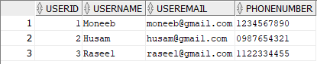

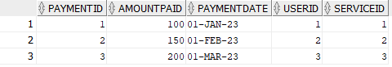

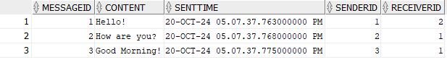

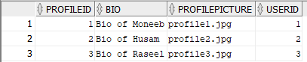

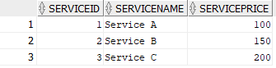

1. Update 1 record from each table using DML commands :

UPDATE Users SET UserEmail = 'moneeb_updated@gmail.com' WHERE userID = 1;

UPDATE Profile SET bio = 'Updated Bio of Moneeb' WHERE profileID = 1;

UPDATE Message SET content = 'Updated Message' WHERE messageID = 1;

UPDATE Service SET servicePrice = 120.00 WHERE serviceID = 1;

UPDATE Payment SET amountPaid = 110.00 WHERE paymentID = 1;

Tables after updating :

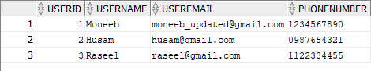

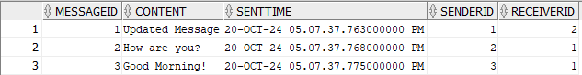

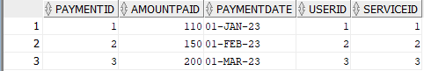

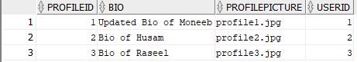

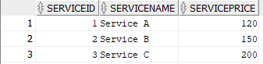

1. Delete 1 record from each table using DML commands :

DELETE FROM Payment WHERE paymentID = 3;

DELETE FROM Message WHERE messageID = 3;

DELETE FROM Profile WHERE profileID = 3;

DELETE FROM Users WHERE userID = 3;

Tables after Delete :

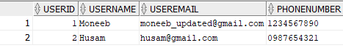

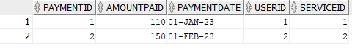

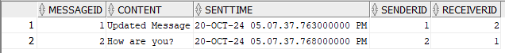

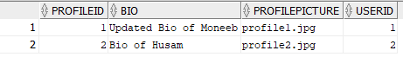

1. Modify 1 of the table's names using DDL commands :

ALTER TABLE Profile RENAME TO UserProfile;

1. Modify 2 columns' names with their datatypes using DDL commands :

ALTER TABLE Users RENAME COLUMN userEmail TO emailAddress;

Table before Rename Colum:

C:\Users\ASUS\Downloads\تعديل اسم العمود 1 (قبل).png

Table after Rename Colum:

C:\Users\ASUS\Downloads\تعديل اسم العمود 1 (بعد).png

ALTER TABLE Payment MODIFY amountPaid DECIMAL(12, 2);

Table before :

C:\Users\ASUS\Downloads\تعديل نوع البيانات قبل.png

Table after :

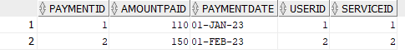

1. Create the class diagram for the system :

